Westville United Methodist Church wants to
Egg Your Yard
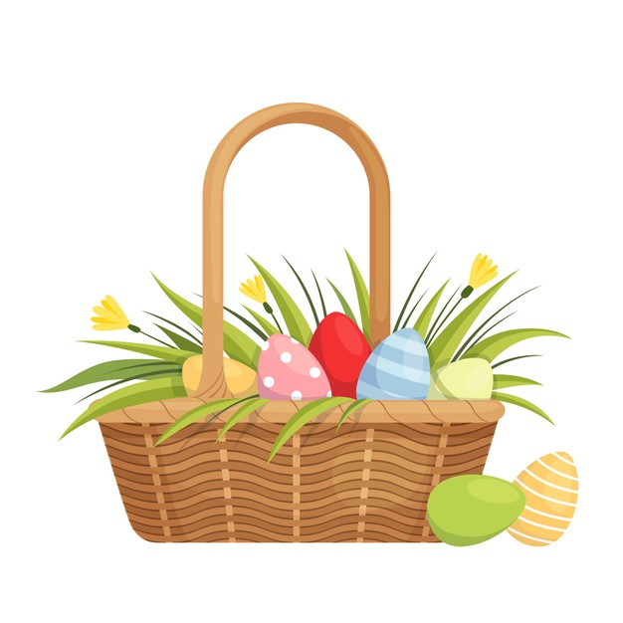
We will deliver Easter eggs filled with candy and trinkets to your home and hide them in your yard (or leave them at your door if you prefer). We will also be providing coloring pages, crayons, and an Easter craft.

$20 for 40 eggs
$10 for each additional 20 eggs
*All proceeds will go to our
Youth Event Outreach Fund

Extra order forms available at the Westville United Methodist Church and the WUMC Resale Shop on Main St.
Delivery Dates: You canchoose between Friday, April 3rd or Saturday, April 4th. We will deliver sometime between 8pm-10pm.

Deliveries will be made in Westville, though nearby locations may be approved on a case-by-case basis.

Deadline for orders and payment: March 27, 2026

Contact Amanda Kelly with questions: 219-229-2765 or ankelly13@gmail.com
*In the event of snow or heavy rain, deliveries will be made to your front door.

Westville United Methodist Church wants to
Egg Your Yard
Help support WUMC Youth by letting us Egg Your Yard. We will deliver filled Easter eggs to your home and hide them in your yard (or leave at your door if you prefer). We’ll also provide coloring pages, crayons, and a craft.
$20 for 40 eggs
$10 for each additional 20 eggs
*Form and payment due by March 27th
Name: ____________________________________________________
Address: __________________________________________________
Phone Number: __________________________________________
Egg My Yard? (Circle One): Egg My Yard Leave Basket at Door
Call or text after delivery? (Circle one) Call Text None
# of Eggs (minimum of 40): ____ # of Children in Household: _____
Allergies or Specific Instructions: _____________________________
Date (Circle One): Friday, April 3rd Saturday, April 4th
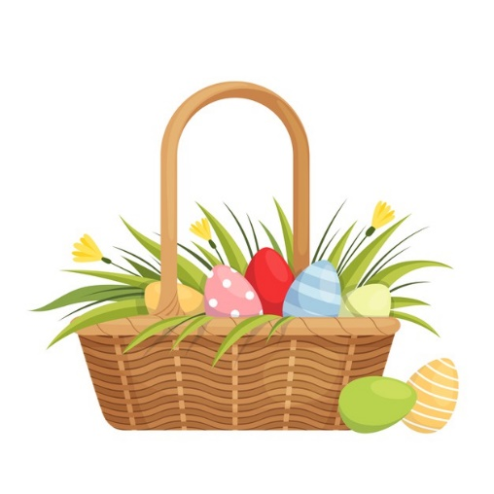
Preferred Time of Egging between 8pm and 10pm (not a guarantee): ________________________________________
Please mail this form and payment to:
Westville United Methodist Church
P.O. Box 619
Westville, IN 46391
*You may also leave the form and payment with cashiers at the Resale Shop on Main St.
Contact Amanda Kelly with questions: 219-229-2765 or ankelly13@gmail.com
*In the event of snow or heavy rain, deliveries will be made to your front door.

